Knowledge organiser for Year 4 – Tudors – Who were the Tudors and what was life like in Tudor Britain?  Curriculum Statement: a study of an aspect or theme in British history that extends pupils’ chronological knowledge beyond 1066.  Overall enquiry question: Who were the Tudors and what was life like in Tudor Britain?  Links to prior learning: Stone age Britain  Links to locality: Prepares for Cornish Rebellion topic in Year 6  Core knowledge in bold  New learning 23-24 |  |  |  | Disciplinary Concepts to be taught:  - Significance  - Continuity and change  - Cause and consequence  - Similarity and difference
Overarching questions | Questions for monitoring | Knowledge |  |  | Vocab
Who were the Tudors and when did they reign?  Understand an aspect or theme in British history that extends pupils’ chronological knowledge beyond 1066.  Significance | Who were the Tudors?  When did the Tudors reign to and from?  How did the Tudors come to power?  Chronologically, what periods of history happened before and after Tudor reign in Britain?  Where does the Tudor reign fit in British history?  What is a dynasty?  Who were the significant people in the Tudor reign?  What unusual things happened in the line of succession in the Tudor reign?  What is a monarch | - The Tudor dynasty ruled England for 118 years, from 1485 to 1603. It was dominated by the long reigns of Henry VIII (38 years) and Elizabeth (45 years).  - The Tudor reign began after the War of the Roses finished in 1485.  - The Tudor reign came after the Middle Ages in British History (link back to this being the period of time when the Great Fire of London took place).  - The Tudor reign was followed by a period of Civil War and revolution, then the Georgian period, a period where sea exploration and the British empire grew then the industrial revolution and Victorian era.  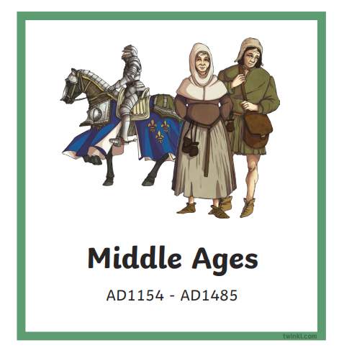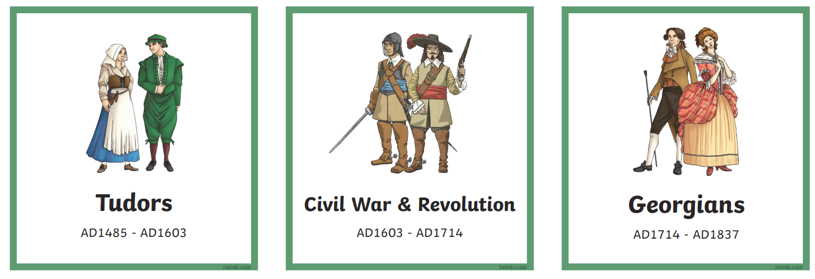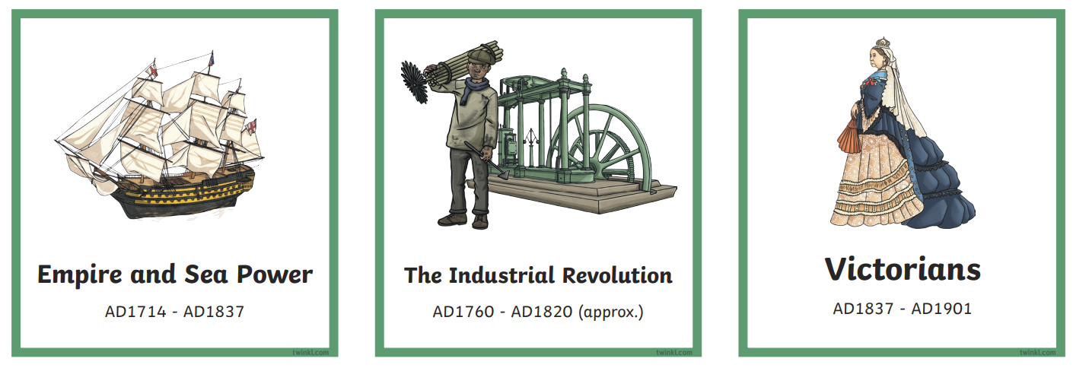  - A dynasty is a line of rulers connected by being related.  - The first Tudor monarch was Henry VII. He defeated Richard III and united the Lancasters and the Yorkists.  - Henry VIII was Henry VII’s son. He ruled for 38 years of the Tudor period and made significant changes to Britain at the time, especially to the Church. He was married 6 times.  - Edward VI was Henry VIIIs son and only reigned as a child for 6 years. He was a protestant.  - Lady Jane Grey was made queen after Edward died because he declared his half-sisters Mary and Elizabeth illegitimate. His advisors encouraged him to do this and to make Jane heir as she was protestant and the granddaughter of Henry VII. Her reign only lasted 9 days before Mary I, the rightful heir to the throne, had Jane imprisoned and took the throne for herself.  - Mary I was a Roman Catholic and the daughter of Henry VIII and Catherine of Aragon, she reversed all the laws Edward had made. She was brutal in her punishments and known as Bloody Mary.  - Elizabeth I was the daughter of Henry VIII and Anne Boleyn. She ruled for 45 years and defeated the Spanish Armada. Her reign was known as the Elizabethan period. She had no children, so the Tudor dynasty ended with her.  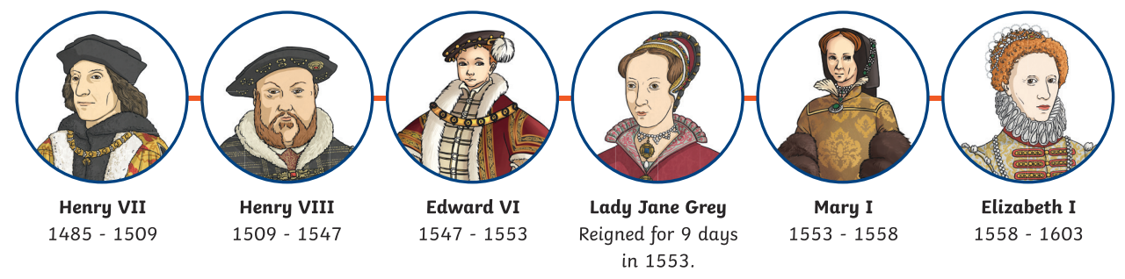 |  |  | dynasty, reign, War of the Roses, Plantagenet, Lancaster, York, Middle Ages, Monarch, illegitimate, heir,
How did the events at the battle of Bosworth and the War of the Roses lead to Tudor Britain?  Understand an aspect or theme in British history that extends pupils’ chronological knowledge beyond 1066.  Justify explanations by making references to appropriate evidence.  Identify and give different reasons for the way the past is represented.  Significance  Continuity and change | What was the War of the Roses?  What led up to the War of the roses?  How did the Tudors come to power?  What happened in Battle of Bosworth?  When did the Battle of Bosworth take place?  What happened after the battle? | - The War of the Roses started because the Plantagenet Family, who were the royal family, had two sides who both claimed they should rule. There was the House of York (white Rose) on one side of the family and the House of Lancaster (red rose) on the other side of the family. Both sides descended from King Edward III. The conflict began between Henry VI from the House of Lancaster and Richard, the Duke of York over who should be king. King Henry was initially too young, then too unwell to reign, so Richard reigned as his protectorate.  - The War of the Roses lasted from 1455 to 1485 and there were several key battles during this time.  - The battle between them for power ended in 1485 at the Battle of Bosworth where Henry VIII (Tudor) beat Richard 3rd. After this battle he Married Elizabeth of York and united the two families, combining the red and white rose to create the Tudor rose.  - On 22 August 1485, Richard III and Henry Tudor faced each other at the Battle of Bosworth Field. Henry Tudor had the support of many rich and powerful people. Initially, the powerful Lord Thomas Stanley and his brother, William, were undecided over who to support. The Stanley’s commanded a force of around 5,000 troops at Bosworth, so their decision over which side to support was crucial. The Stanleys waited until the last moment to decide to support Henry over Richard. Many historians believe the Stanley's support was the deciding factor in the defeat of Richard III. It is believed the Stanleys thought a victory for Henry would help to increase their own wealth and power. Richard III was killed at the battle and Henry VII took the throne.  - After the battle, Henry VII married Edward IV’s daughter, Elizabeth of York, bringing the houses of Lancaster and York together in peace. He united the York and Lancaster roses to create a new symbol - the red and white Tudor rose. The reign of the Plantagenets was over and the reign of the Tudors had begun. |  |  | reign, War of the Roses, Plantagenet, Lancaster, York, heir, Tudor rose
How was life different for the rich and the poor in Tudor Britain and how do we know?  Understand an aspect or theme in British history that extends pupils’ chronological knowledge beyond 1066.  Justify explanations by making references to appropriate evidence.  Similarity and difference  Look at a range of sources to gather this information, including portraits and texts. Evaluate the effectiveness of these sources. | What was similar and what was different about the life of rich and poor Tudors from one another?  What is similar and what’s different from Tudor Britain to life in Britain today?  What is a source?  What is a primary source?  What is a secondary source?  Which sources do you think are most reliable?  Which sources have limitations?  What is bias? | - Rich Tudors had plenty of food they ate a lot of meat and had sweet puddings. Meats could include partridge, lark, peacock, seagull, venison, mutton and pork. Puddings included jellies, fruits, and pies.  - Rich Tudor clothing was soft and included velvet and satin. Sometimes they wore a starched ruff around their neck.  - Rich Tudor boys were educated, and Tudor girls were married young – often to advance the family.  - Rich Tudor houses were large and had lots of windows. Oak panelling was used to keep rooms warm.  - Rich Tudor Beds were four poster and draped in fabric.  - Poor Tudors mostly ate bread and vegetables, sometimes they may have eggs and cheese but not very much meat.  - Poor Tudor clothing was warm, and durable made from wool. Shoes were made from wood.  - Poor Tudor boys went to work and poor Tudor girls helped with chores at home.  - Poor Tudor houses were made from wood, wattle and daub (twigs and clay). Most families lived in one room.  - Poor Tudor beds were stuffed with straw.  - Similarities for the Rich and Poor in Tudor Britain:  - Disease was everywhere and people often died very young from disease.  - The water was so dirty and contaminated with sewage, it couldn’t be drunk so people drank ale.  - Hats were worn every day by men and women.  - Primary sources are evidence produced during the period itself.  - Secondary sources are evidence produced afterwards by people studying the period of history.  - The mot reliable sources are artefacts from the period or sources such as photographs (but cameras weren’t invented in the Tudor reign).  - Portraits, diaries and accounts from the time are less reliable because they are based on people’s opinions and susceptible to bias.  - Bias is when you have a reason to favour one side or argument over another and show favouritism towards that point of view.
Why was Henry married so many times and how did his marriages impact Britain? | Who were Henry’s 6 wives?  Why did he marry each one?  What happened to each wife?  How did Henry’s marriages impact Britain at the time?  What was the impact of Henry’s marriages on life in Britain today? | - Catherine of Aragon was a Spanish princess, she had been married to his older brother Arthur, but he died just months after they were married so Henry married her. They had several children together but only one, Mary (who later become Mary I) survived. Henry wanted a son and became frustrated with Catherine not producing one. He wanted to marry one of the ladies of her court, Anne Boleyn but he had to divorce Catherine first. He asked the pope to annul his marriage, but the Pope refused. Henry was so angry he split from the Roman Catholic church and appointed himself the head of the church. This allowed him to divorce Catherine and marry Anne. Catherine spent the rest of her life in a nunnery unable to see her daughter unless she accepted Anne as queen, which she refused to do. She died aged 50.  - Anne Boleyn was Henry’s second wife. She had previously lived in a French court and knew how to make friends and influence people. She was very attractive and caught Henry’s eye. At the time women weren’t allowed a lot of opinions but she has them and influenced Henry a lot. Sometimes they argued about this. They had a daughter (Elizabeth I) but when they failed to have a son, Henry started courting Jane Seymour. This made Anne mad. Henry accused her of being unfaithful and had her beheaded.  - Jane Seymour came from a wealthy British family. She was Anne’s lady-in-waiting. She was engaged to Henry the day after Anne was beheaded and they were married within two weeks! She was close to Mary I and tried to repair her relationship with her father, henry. She gave birth to a son but developed and infection and died. Henry was devastated.  - Anne of Cleves the fourth wife. She was a German princess who Henry married to improve England’s relationship with Germany. He was sent a portrait of her that convinced him to marry her but when he met her, he complained that she wasn’t as pretty as in the portrait. They were married for 6 months before he had their married annulled (a type of divorce). She went along with this and as a reward was given land and riches.  - Catherine Howard was married to King Henry when she was just 17. He was significantly older. She was younger than his oldest daughter Mary. Henry discovered she was having a relationship with Thomas Culpeper, a groomsman, and had her beheaded.  - Catherine Parr was Henry’s last wife. She was a widow, having lost two husbands. She married Henry when she was 32 and he was 51. She was highly educated and good at acting in affairs of state. She worked hard to reunite Henry with his daughters and managed to get him to put them back in the line of succession. Henry died, leaving her a widow and she went on to marry her sweetheart Thomas Seymour and have a daughter with him. She survived him.  - Henry married Catherine Aragon and Anne of Cleves to improve relationships with France and Germany. He married Anne Boleyn and Jane because he found them attractive, and they came from wealthy important families. Catherine Howard and Catherine Parr both came from respected and wealthy families.  - Henry’s divorce from Catherine of Aragon caused the Church of England to be created.
How did Christianity in England change throughout the Tudor reign?  Understand an aspect or theme in British history that extends pupils’ chronological knowledge beyond 1066.  Continuity and change | What is a protestant?  What is a Catholic?  Who is the pope?  How did the Church of England come to exist?  Why did Henry break from the Roman Catholic Church?  Which monarch was Protestant and Catholic?  How did the Monarch’s religious beliefs change Britain? | - For most of his life, Henry was a devout Catholic. He attended Mass daily and went on Catholic pilgrimages to holy sites. His closest advisor was Cardinal Wolsey, the head of the Catholic Church in England.  - In 1517, a German priest named Martin Luther published a series of criticisms of the Catholic Church. This was the beginning of a new branch of Christianity, which became known as Protestantism, as it began as a protest against the Catholic Church  - Protestants believe individual believers should have a relationship with God, not just through a priest.  - Roman Catholics believed the Pope and priests were essential for their relationship with God, seeing them as the only way to have a relationship with God.  - The Pope is the leader of the Roman Church. Catholics believe he was chosen by God and is God’s representative on earth.  - Henry created the Church of England because he wanted to divorce Catherine of Aragon and the Pope wouldn’t let him. The church was also very rich and by ‘owning’ it, he could begin the ‘dissolution of the monasteries. This meant closing some of the monasteries, selling their land and taking their gold and goods. Breaking with Rome allowed Protestantism to grow in England however Henry never became a protestant. This suggests he broke from Rome for reasons other than religion. The introduction of Protestantism was known as the reformation.  - For centuries to come, after Henry’s death, the religion of the monarch would affect how the country was run. At the time, England and its people were very religious. During the Tudor reign, the King or Queen often told them what to believe and how to worship, which was very difficult for people if they didn’t agree. Lots of laws were made about religion.  - Henry VII was a Roman Catholic and led a Roman Catholic country. Services were held in Latin.  - Henry VII was a Roman Catholic and defended the church from Protestantism UNTIL he split from the Church, started the Church of England and made himself the head of the church (equivalent of the pope). This was called the Reformation, and he passed a law called ‘The Act of Supremacy’ in 1534 to make himself the head of the church. In 1535, he closed the Roman Catholic Abbeys, Monasteries and convents. However, England remained Catholic until Henry’s death.  - Henry’s son, Edward VI, and his advisors made England Protestant when he took the throne in 1547. Services were then held in English and a new prayer book was introduced. Catholics were treated badly, and a new Prayer book was introduced. The Bible was now also written in English. Churches were more modestly decorated.  - Lady Jane Grey kept the country Protestant.  - Mary changed England back to a Catholic country with the pope as head of the church. Services went back to Latin. She burned 300 leading protestants who would not convert to Catholicism.  - Elizabeth turned England back into a protestant nation; The Church of England became the dominant church. She tried to establish peace between Catholics and protestants. She allowed priests to continue working and produced a prayer book in both Latin and English. She punished people who were extreme Catholics or Protestants who tried to convert others. Services changed back to English.  - Britain is still a protestant country today. |  |  | Catholic, Protestant, pilgrimage, mass, pope, monastery, Act of Supremacy.
How did Tudor explorers change the future of Britain?  How was Elizabeth able to defeat the mighty Spanish Armada?  Understand an aspect or theme in British history that extends pupils’ chronological knowledge beyond 1066.  Significance  Cause and consequence | When did explorations begin?  Why were people exploring?  Who were the famous explorers in Tudor Britain?  What did the discover?  What made them famous?  What was the Spanish armada?  Why did it attack England?  How did England defeat the Armada? | - English exploration began in the reign of Henry VII, who sent navigator John Cabot to find a northwestern route to Asia.  - During the reign of Elizabeth 1, many sailors went in search of unknown lands. There were two main reasons: one was adventure and the other was money.  - Sir Walter Raleigh was one of the first famous Tudor explorers. He was a handsome man and was one of Elizabeth I's favourite courtiers. He led many expeditions to America and introduced tobacco and the potato into England. He chose the name of the first English colony in America. He named it Virginia after Queen Elizabeth. Elizabeth didn't like her courtiers to fall in love with anyone except her. Sir Walter lost her friendship after he fell in love and married one of Elizabeth's maids of honour. He was briefly sent to the Tower of London.  - Another famous Tudor explorer was Sir Francis Drake. Sir Francis Drake was born in 1540 in Devon. He became famous as a pirate and explorer. During his life, Protestant England was at war with Catholic Spain and there were rich rewards for capturing Spanish ships. Drake captured many Spanish ships. His pirate raids on Spanish ships off the coast of America were encouraged by Queen Elizabeth I. Drake's successful battles against the Spanish helped England become a major sea power. He was the first Englishman to sail around the world, which he did (1577 - 1580) in his ship ‘The Golden Hinde’. Drake started his famous circumnavigation of the world from Plymouth, in 1577.  - On the way round the world, Drake landed in what is now California, naming it Nova Albion (New England) and claiming it for his queen.  - Drake returned from his voyage with his ship packed full of spices from the Indies and plundered Spanish silver and treasure.  - Drake was knighted by Queen Elizabeth l for his courage, and for the treasures he brought back with him. He brought back enough treasure to pay off the entire national debt.  - In 1587, Elizabeth I put Drake in command of an expedition to attack a Spanish fleet which was getting ready to attack England. Drake sailed right in to Cadiz harbour and wrecked the ships there, before going on to capture another hundred Spanish ships elsewhere.  - As a sailor, adventurer, navigator, politician, engineer and landowner, Drake was one of the most famous men in Elizabethan times.  - In 1588 a massive invasion fleet or 'Armada' sailed from the port of Lisbon. It was made up of 130 ships fitted with 2,500 guns. They carried 30,000 soldiers and sailors. This great war fleet was bound for England. This was the Spanish Armada. At that time England was a small nation with a little navy and they were facing the greatest power in the world (Spain). They defeated Spain, with help from Mother Nature. It marked the beginning of England's mastery of the seas.  - The Spanish monarch, Philip II, was angry that Queen Elizabeth had not punished Sir Francis Drake and other English seadogs for plundering Spanish ships. Philip was a devout Catholic. He felt it was his duty to invade and conquer England in order to convert the country back to the Church of Rome.  - On 6 August 1588, the Spanish Armada anchored at Calais. The English filled eighty ships with flammable material and set fire to them. They sent in fireships to panic the Spaniards and scatter the Armada's formation. (The Armada's formation, the famous crescent, had proved extremely successful in previous campaign as it allowed all ships to fire their heavy guns simultaneously.) The Spanish panicked and fled to the open sea, straight into the gunfire of the waiting English. The wind blew the Spanish ships northwards which helped the English. Strong winds and terrible rain forced many ships onto rocks near Ireland. |  |  | Navigator, Armada, colony, circumnavigation,
End of unit check – complete end of unit check and answer the question ‘Who were the Tudors and what was life like in Tudor Britain?’ |  |  | dynasty, reign, War of the Roses, Plantagenet, Lancaster, York, Middle Ages, Monarch, illegitimate, heir, Tudor rose, Catholic, Protestant, pilgrimage, mass, pope, monastery, Act of Supremacy, Navigator, Armada, colony, circumnavigation,

