Music development plan summary:
St Mewan Primary School

Overview
Detail | Information
Academic year that this summary covers | 2024-2025
Date this summary was published | September 2024
Date this summary will be reviewed | September 2025
Name of the school music lead | Laura Yeo
Name of school leadership team member with responsibility for music (if different)
Name of local music hub | AsOne
Name of other music education organisation(s) (if partnership in place) | CMST  Rocksteady

This is a summary of how our school delivers music education to all our pupils across three areas – curriculum music, co-curricular provision and musical experiences – and what changes we are planning in future years. This information is to help pupils and parents or carers understand what our school offers and who we work with to support our pupils’ music education.

Part A: Curriculum music
This is about what we teach in lesson time, how much time is spent teaching music.
Our school Music curriculum is taught through the scheme of Sing Up which meets the requirements of the National Curriculum for Music and approaches of the Model Music Curriculum. Throughout the scheme it uses a variety of skills such as listening and appraising, composing, ensembles and performing individually and within a group. The Sing up scheme also provides a range of ideas on how to support children who need additional help or those who need further challenge.
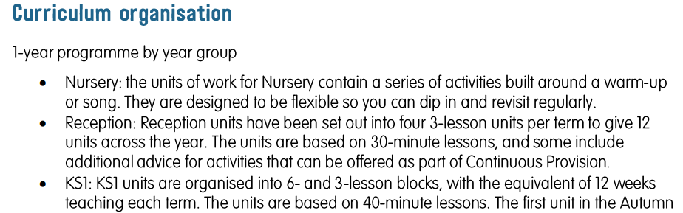
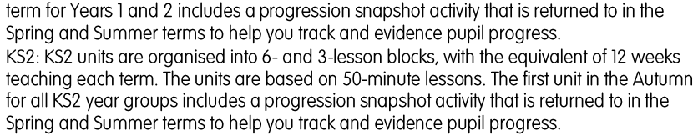

How Music is taught at St Mewan for children with Special Educational Needs (SEND)

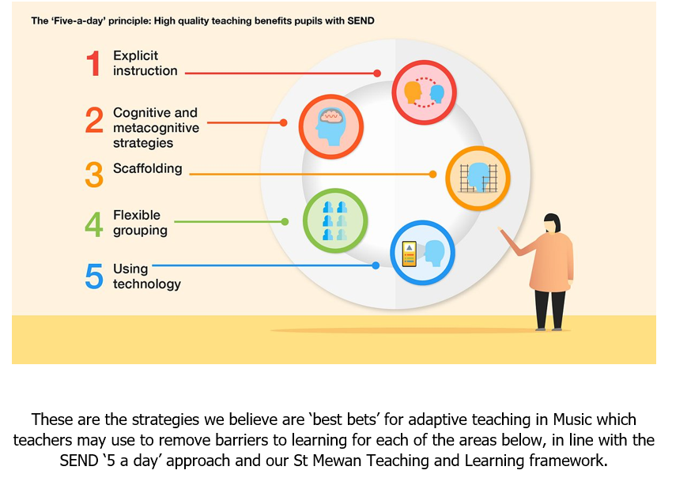
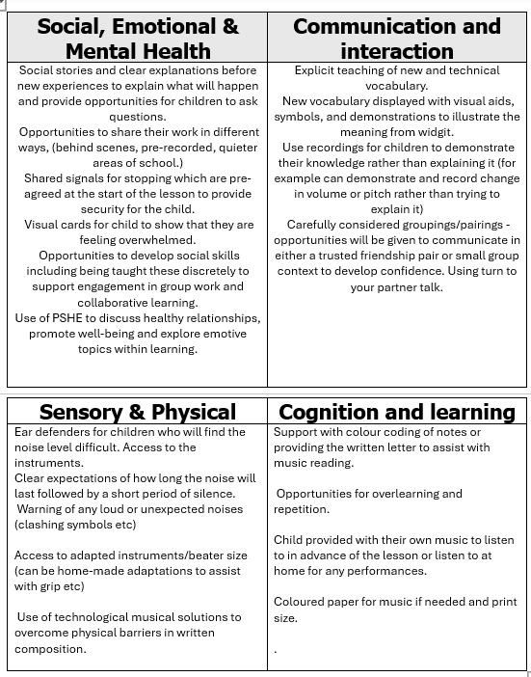

Part B: Co-curricular music
This is about opportunities for pupils to sing and play music, outside of lesson time, including choirs, ensembles and bands, and how pupils can make progress in music beyond the core curriculum.
We currently offer peripatetic lessons in singing, keyboard, clarinet, flute and violin. These lessons can be subsidies for anyone eligible for pupil premium.
We will also be offering Rocksteady lesson for children this year which are paid for by the parents/guardians. The children will have the opportunity to learn an instrument as part of a band. They will have the choice of electric guitar, keyboard, drums or vocals.

As children move into Key Stage 2, they learn how to play recorders or ukuleles with their class teacher and keyboards with the Cornwall Music Services through a scheme called ‘First Access.’ These are free of charge. Year 2-6 have an opportunity to join the school choir, performing in concerts at school, in the community or with other local schools and at exciting venues e.g. The O2 arena in London. All of our children have the opportunity to perform solo or with their classmates during music lessons, Christmas shows, end of year shows or singing assemblies.

Part C: Musical experiences
This is about all the other musical events and opportunities that we organise, such as singing in assembly, concerts and shows, trips to professional concerts and achieving musical awards.
This year at St Mewan we will be running a KS1 and a KS2 weekly singing assembly in which all children will have the opportunity to sing as part of a large group.
KS1 will perform a Christmas show in which they will perform to live audiences.
Year 1 will have the opportunity to sing within the local community throughout the year.
Year 2 will take part in the ‘Big Sing’ run by Asone. The children will be taught some songs to sing together on the day.
Year 3 will have the opportunity to go to the Hubbub festival run by Asone where the children will have a range of workshops to attend.
Year 4 are able to learn an instrument as a whole class taught by a music specialist as part of a ten-week programme. This if funded by Asone and the instrument hire is funded by the school.
Year 5 will participate in Songfest. A small amount of children will attend the concert in the evening in person. The remaining children will join in with the virtual concert in school. They will focus on a range of songs picked by Asone and perform as a large choir.
Year 6 – In Year 6 they will prepare an end of year show and perform it to a live audience. A small number of children may also attend the CELT singing performance.

In addition to this, the choir will run for children Year 2-6. We will be going to perform in the Young Voices concert at the 02 arena in which year 5 & 6 children can attend. We will also do additional performances in care homes in the community throughout the year in which the whole choir can attend.

Children who attend instrumental lessons will have the opportunity to perform in St Austell and Truro Music Festival. They also have the chance to work towards ABRSM graded exams. Pupil premium funding is also available for instrumental lesson. Please get in contact with the school if you wish to find out more.

We will also be offering Rocksteady lesson this year where parents can sign up with this company for children to learn an instrument as part of a band. They will have the choice of electric guitar, keyboard, drums or vocals and enjoy playing in a happy, supportive environment with their friends.

Most of the opportunities provided are funded by Asone or the school except for transport.

*All the above opportunities are subject to change depending on what Asone offers this year.

In the future
This is about what the school is planning for subsequent years.
Next steps:
- Broaden instrumental lessons to include brass instruments.
- Continue to embed the new curriculum and make any changes to units based on feedback from children and staff throughout the year.

Further information (optional)
“ASONE Perform CIC became the lead organisation for the music hub in Cornwall. The ASONE Hub is a partnership of local and regional organisations working together to support the music education of young people in Cornwall. The Hub leads on the strategic development of music education locally and works with a variety of organisations and individuals to meet local needs. We are constantly striving to ensure that we reach all children and young people, regardless of age, location or interests.”
PROGRAMME | ASONE Hub (asoneperform.com)

